  North Wales Fire & Rescue Service | 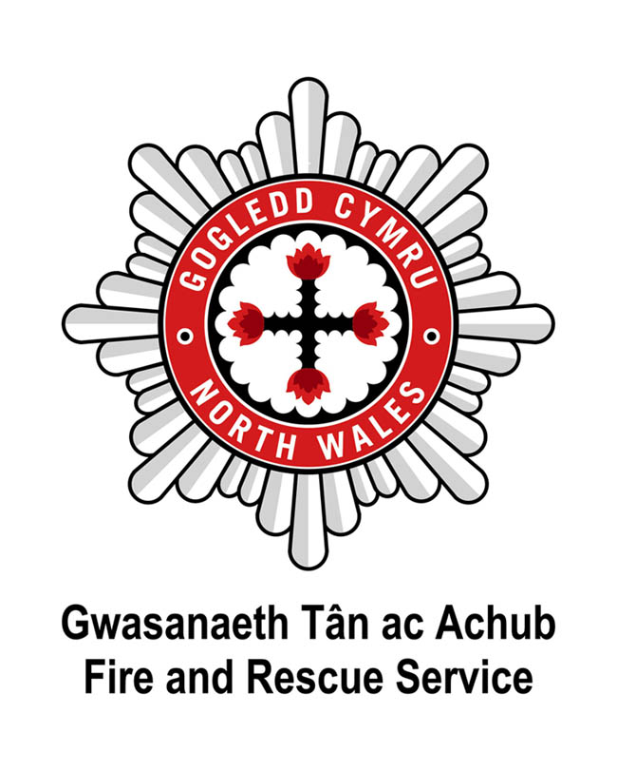

PQA Interview Guidance for Applicants

What to Wear:
You will not be assessed on your standard of dress - however it is important that you are clean and smart. Remember that you are applying to enter a disciplined environment and should you be successful in the process you will be required to adhere to strict standards of appearance and dress.

How to Prepare:
Firstly, if you have not done so already, you should visit www.nwales-fireservice.org.uk to develop a full understanding of what we do and the role of Firefighters in achieving our goals. Ensure you know about the variety of tasks and duties that a Firefighter undertakes.

If you have one, read over your CV – this will help you to remember all of the positive things that you have achieved. If you have just left school and haven’t had any work experience, focus your attention on your achievements in school and any clubs that you may be a member of. When you are asked questions at interview about your skills and experiences, it’s useful to draw on skills and experiences you have achieved from a range of different situations and places.

Practice talking about your skills and experiences out loud, this practice will help you to talk confidently about your achievements at interview.

Look at the Person Specification and consider what types of questions the interviewers might ask for this job. If you were the employer, what would you want to ask?

You should ensure that you have read and understood the Job Description, and it may assist you to do some additional research into the legislative framework around the role.

Type of Questions:
In addition to questions that will explore your knowledge of the role and its requirements, you will be asked questions about your personal qualities and attributes (PQAs) so the interview panel can consider whether you have the potential to carry out the role. The PQAs that will be explored at interview are noted below; because they measure your behaviour, they are also known as Behavioural Indicators.

You will be asked to reflect on personal experiences from your own life that you can use to illustrate PQA-specific behaviour.

To help ensure fairness, all candidates will be asked the same questions; however the interviewers may also ask supplementary or probing questions in order to assist you to explore your answer in detail.
Type of Answers:
Evidence of past performance is regarded to be the best indicator of a candidate’s likely future performance. It is important that you provide as much information about your actual past experience as possible to assist the interview panel in establishing whether you have the potential to transfer your skills and experience to the role of Firefighter.

Try to give ‘STAR’ answers when you are asked to provide examples of your experiences, this will allow you to provide relevant, detailed and concise responses.

S T A R

SITUATION TASK ACTION RESULT

Remember to talk about YOUR personal experience, what situation YOU were in, what task YOU had, what action YOU took to achieve a positive result.

Your answers must be truthful; any proven and factual evidence that examples are fabricated will result in applications being withdrawn.

Interview Scoring:
The interview panel will be assessing your answers against pre-agreed positive indicators / expected responses. Interviewers are only permitted to provide scores against information and evidence you provide during the interview, they cannot take into account any inferences or assumptions - this is why it is important that you provide full and detailed answers.

All interviewers have been trained to meet the same standards of interviewing and to use the same scoring methods and quality assurances are in place.

The role of the interview panel is to help you to relax and encourage you to give your best – you will not be asked anything to trip you up.

Personal Qualities and Attributes

On the following pages you will find an outline of the Personal Qualities and Attributes (PQAs) that Firefighters are required to demonstrate throughout their work.

It is advised that you invest time reading and understanding how these behaviours apply to real life experiences that you have had.

Please note; you will not gain additional credit for learning or being able to recite the PQAs. The process is designed to identify that you naturally apply them in your interactions with others and in real life situations.

Canvassing by an applicant of members of the Fire & Rescue Authority or Recruitment Team, either directly or indirectly, will disqualify the applicant concerned for the appointment.

The National Firefighter Selection Personal Qualities and Attributes (PQAs)

Commitment to Diversity and Integrity - understands and respects diversity and adopts a fair and ethical approach to others

- Is concerned to treat people fairly and ethically (e.g. completes work according to same high standards regardless of individual differences)

- Recognises the importance of an awareness of the community and understands its needs (e.g. is aware and respectful of differing cultures and backgrounds)

- Recognises and has respect for others’ backgrounds, views, values and beliefs (including religious beliefs)

- Maintains an open approach with others, taking account of, and accepting, individual differences such as age, ethnicity, gender, religious beliefs, social background, disability, sexual orientation and physical appearance

- Is committed to the Fire and Rescue Service values and actively promotes them (e.g. challenges inappropriate behaviour)

- Is honest when working with others and accepts accountability for own actions (e.g. quickly takes responsibility for own mistakes; respects the need for confidentiality: is trusted to enter others’ homes).

Openness to Change – is open to change and actively seeks to support it

- Demonstrates an understanding of the need for progress within the Fire and Rescue Service (e.g. explains the reasons for new working practices to colleagues absent from briefings)

- Accepts change both within the Fire and Rescue Service and in their own role and adapts effectively (e.g. willingly participates in community fire safety activities)

- Is aware of the impact of changes to the Fire and Rescue Service on their role (e.g. understands changes to working practices)

- Identifies ways, both within the Fire and Rescue Service and the local community, of supporting change and takes action where possible (e.g. is proactive in learning new tasks or ways of working)

Confidence and Resilience - maintains a confident and resilient attitude in highly challenging situations

- Remains in control of own emotions during emergency situations (e.g. does not panic and considers risk)

- Concentrates on the task despite pressure (e.g. pressure of time, noise, conflicting information and tasks, and concern for casualties)

- Challenges or questions others constructively to achieve more effective outcomes

- Retains confidence in own ability or convictions despite setbacks (e.g. after a community fire safety talk is received poorly)

Working with Others - works effectively with others both within the Fire and Rescue Service and in the community

- Works effectively with all team-members according to defined role (e.g. in teams of 2 and up to teams of 20), adjusting his/her role in accordance with instructions and changing circumstances

- Proactively generates positive working relationships, building rapport with a range of people both internally (e.g. attempts to get to know everyone in working environment) and externally (e.g. liases with community groups to promote fire safety; works well with other emergency services)

- Concerned about the wider team and aware of shared objectives, as well as those of his/her immediate work-team (e.g. willing to give community fire safety talks at schools)

- Sensitive to the feelings and well-being of others and takes action to support them (e.g. able to reassure and calm members of the public in emergency situations; reminds team member to check air when using breathing apparatus)

- Presents an approachable and positive image of self and the Fire and Rescue Service to everybody in the community, irrespective of individual differences

Effective Communication– communicates effectively both orally and in writing

- Communicates verbal messages clearly, concisely and at a level appropriate to the audience so that message is understood regardless of individual differences

- Is sensitive to the needs of the audience and tailors communication in response to feedback (e.g. able to convey the importance of fire safety without distressing members of the public unnecessarily)

- Constantly alert for new information and listens actively to ensure accurate understanding (e.g. using appropriate body language, or by asking questions)

- Asks appropriate questions and checks understanding to ensure all messages received and sent are clearly understood (e.g. asks colleague to repeat message)

- Communicates effectively with both small and large groups

- Presents messages (e.g. fire safety information) in a way that promotes understanding (e.g. uses slides, videos and other visual aids appropriately during presentations and fire safety visits; engages with the audience)

- Writes clear, basic and appropriate information or messages that are understood by the recipient (e.g. completes standard Fire and Rescue Service forms and uses the Breathing Apparatus operations entry control board correctly)

Commitment to Development - committed to and able to develop self and others

- Proactively reviews own performance using a variety of sources including seeking feedback from others (e.g. uses incident debriefs and personal development reviews to inform development)

- Identifies development needs in own knowledge, skills and understanding and takes action to improve (e.g. requests specific training as appropriate; makes a point of keeping up-to-date with changes in technology/procedures and incident type; recognises that own fitness levels need to be improved)

- Learns from a wide range of situations experienced by self or others (e.g. increases understanding about a community group following a safety discussion)

- Able to learn and retain a large amount of job relevant information, delivered both verbally and in writing, as part of an initial training course and ongoing development (e.g. operating procedures and standards)

- Actively encourages and supports others to continuously improve (e.g. updates colleagues concerning new information; participates in a mentoring programme to support new members of staff)

- Motivates self to keep relevant knowledge up-to-date

Problem Solving - understands, recalls, applies and adapts relevant information in an organised, safe and systematic way

- Able to recall and apply relevant job related information and procedures during incidents, does not take information at face value when making a decision (e.g. does not assume that one casualty has been able to provide accurate information about other occupants of a building)

- Applies, and, if necessary, adapts current procedures and practices and to take account of a changing environment and to minimise risk

- Generates more than one solution to a problem and evaluates which one is best (e.g. in deciding how best to promote community fire safety)

- Considers immediate and wider objectives and implications (e.g. health and safety) to plan ahead to complete tasks in most efficient and safe way

- Prioritises, plans and completes tasks in a logical and systematic manner despite conflicting information (e.g. able to manage own actions during emergency situations)

- Able to understand, interpret and manipulate basic numerical information (e.g. in dials, tables, charts) and use basic arithmetical calculations correctly to apply task procedures (e.g. able to work out operation times when using Breathing Apparatus equipment)

Situational Awareness - maintains an active awareness of the environment to promote safe and effective working

- Constantly checks the environment and takes action to ensure safe working (e.g. looks for and assesses risks to safety of self and others

- Has awareness of a range of safety related information without becoming unduly focused on any one piece of information (e.g. considers full range of factors at an incident such as location of team members at an incident)

- Provides timely and accurate information to confirm progress and outcomes against objectives (e.g. keeps team informed at incidents of changing circumstances)

- Able to judge space and distance within three dimensions and time to perform tasks safely and effectively (e.g. able to judge space and distance to work with ladders)

Commitment to Excellence - Adopts a conscientious and proactive approach to work to achieve and maintain excellent standards

- Continually looks to improve standards of working and offers suggestions as necessary (e.g. provides feedback concerning new or existing work practices to influence change or improve service delivery)

- Approaches work proactively and efficiently both with routine tasks and during incidents

- Adopts a conscientious approach to work (e.g. checks work to ensure all tasks completed correctly and with due attention to detail; maintains appropriate levels of personal fitness

- Completes work using appropriate procedures (e.g. refrains from taking unsafe short-cuts)

- Completes work as instructed without being reminded constantly

- Is clear about the role of the Fire fighter and operates within agreed levels of authority and accountability (e.g. does not take action outside own level of control without seeking confirmation)

- Demonstrates a commitment to the work of the Fire and Rescue Service, viewing its role as socially important

